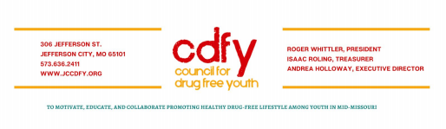April Coalition Meeting
April 8, 2021
11:30 – 12:30 pm

Attendees: Roger Whittler, Andrea Holloway, Cotton Walker, Amy Rogers, Gabriella Williamson, Tiffany Steen, Darcy Crane, Zackery Reimund, Tijera Safir, Aston Frank, Audi Palaniappan, Judy Brooks

Call Meeting to Order – President – Roger Whittler called the meeting to order
● Approval of Minutes – Roger Whittler made a motion we approve the minutes, Gabriella Williamson seconded the motion, Motion Carried
● Introductions – Everyone introduced themselves
Guest Speaker – Tiffany Steen - Community Outreach Specialist, Burrell Behavioral Health – Tiffany presented a very informative and interesting presentation. Tiffany has worked with several mental health and substance abuse organizations.
● Topic: Marijuana: Self Medication Amongst Youth in Mid Missouri – Tiffany had many statistics to share with us. Some were the impact of Marijuana on the functioning of the brain. One statistic is how much marijuana has increased over cigarettes amongst the youth. Another is that the average age of 14 or 15 is when the youth start. At this age the brain has not fully developed.
● Q & A – The question of how we get to the parents without mentioning parent role in dealing with the youth. We definitely need to educate the parents on the facts and effects about marijuana.
Discussion:
● How can we make the community aware? – Tiffany gave steps to help: Treatment – CBT Therapy Continency Management Motivation Enhancement
● What steps could CDFY implement? - Prevention Suggestions: Positive role models, Schools offer education, Talk about the risk, Parent encouragement of self-worth and confidence, Therapy Education, Setting boundaries, Set goals, Permissive parents increase risks, Early intervention.

2021 Calendar
EVENTS
- CDFY Strategic Planning Meeting
  - April 13, 2021 at 1:45 pm (zoom/CDFY office)
  - April 22, 2021 at 1:30 - 3 pm (zoom/CDFY office)
- CDFY Membership Committee Meeting - April 13, 2021 at 10 am (Zoom/CDFY office)
- DEA National Prescription Drug Take Back Day - April 24, 2021 10 - 2 pm.
- Annual Banquet - April 30th
- 5K Run/Walk - 5/1/21 - Don’t forget to register whether running or volunteering!
- CDFY Community Outreach Meeting - May 4, 2021 at noon (zoom/CDFY office)
- Kidsfest - June 5, 2021 10 am - 2 pm Need 4 volunteers for two 2-hour shifts. Volunteer sign-ups are on CDFY website.
- Opioid Summit: Planning for Late June to Early July - More details to come!

MAY GUEST SPEAKER - May 13, 2021 at 11:30 am via Zoom
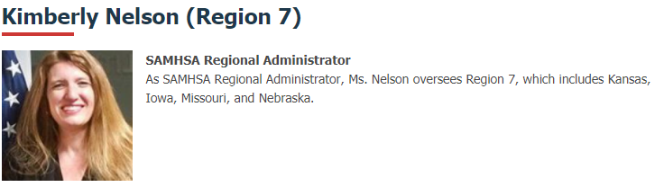
COALITION MEETING REMINDER - 2nd THURSDAY of EVERY MONTH!
Meeting adjourned
Next Meeting May 13, 2021 via Zoom

